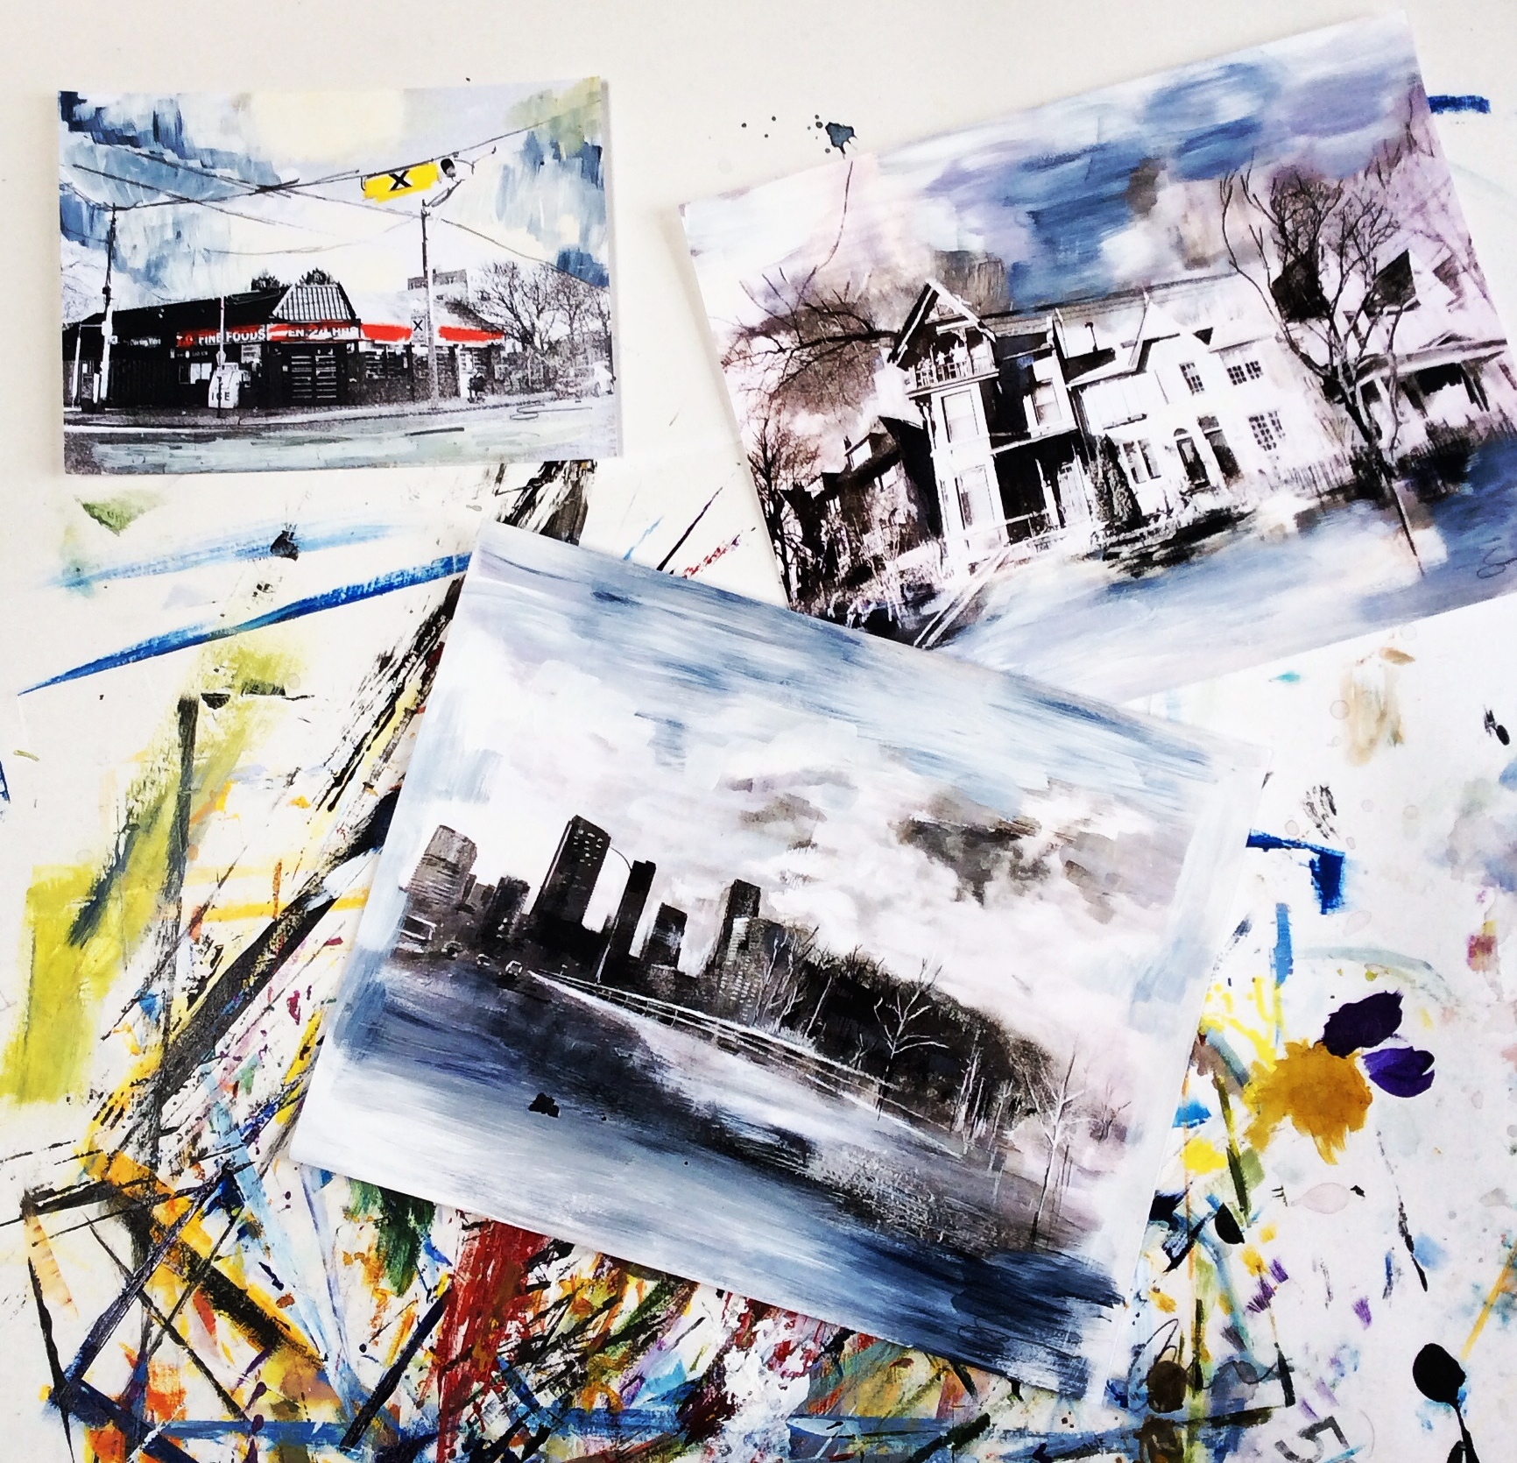
  October | 2017
  Upcoming UNCONVENTIONAL WREAt OR MOBILE MAKING
  PAINTED PHOTOGRAPH FAMILY PORTRAIT
  –>3 week pre registered <–
  COLLAGE BASED MIXED MEDIA
  WATERCOLOUR FALL LANDSCAPE
  Haunted full moon on the water painting & Pastels

Monday | Tuesday | Wednesday | Thursday | Friday | Saturday | Sunday
 |  |  |  |  |  | 1
 |  |  |  |  | Wakefield studio tour -open house -10-5  John Pagani | Community center:  12-1pm parent child craft former  2-3:30pm Adult acrylic painting  (pre -registered)
2 | 3 | 4 | 5 | 6 | 7 | 8
 |  |  | 6:30- Youth Painting at the Wakefield community center (pre-registered) | 7:00-9:00PM  UNCONVENTIONAL WREATH OR MOBILE MAKING  Accompanied Live Music by Mathew Falvai | Oct 7, 14,21, 7:00-9:00PM  PAINTED PHOTOGRAPH FAMILY PORTRAIT  –>3 week pre registered <– | Parent Child class might be added please email if interested
9 | 10 | 11 | 12 | 13 | 14 | 15
Thanksgiving |  |  | 6:30- Youth Painting at the Wakefield community center (pre-registered) | 7:00-9:00PM  COLLAGE BASED MIXED MEDIA  Accompanied Live Music by Mathew Falvai | OCT 7, 14,21,  7:00-9:00PM  PAINTED PHOTOGRAPH FAMILY PORTRAIT  –>3 week pre registered <– | Community center:  12-1pm parent child craft former  2-3:30pm Adult acrylic painting  (pre -registered)
16 | 17 | 18 | 19 | 20 | 21 | 22
 |  |  | 6:30- Youth Painting at the Wakefield community center (pre-registered) | 7:00-9:00PM  WATERCOLOUR FALL LANDSCAPE | OCT 7, 14,21  7:00-9:00PM  PAINTED PHOTOGRAPH FAMILY PORTRAIT  –>3 week pre registered <– | Community center:  12-1pm parent child craft former  2-3:30pm Adult acrylic painting  (pre -registered)
23 | 24 | 25 | 26 | 27 | 28 | 29
 |  |  | 6:30- Youth Painting at the Wakefield community center (pre-registered) | 27, 2017 7:00-9:00PM  Haunted full moon on the water painting & Pastels  Accompanied Live Music by Mathew Falvai |  | Community center:  12-1pm parent child craft former  2-3:30pm Adult acrylic painting  (pre -registered)
30 | 31

