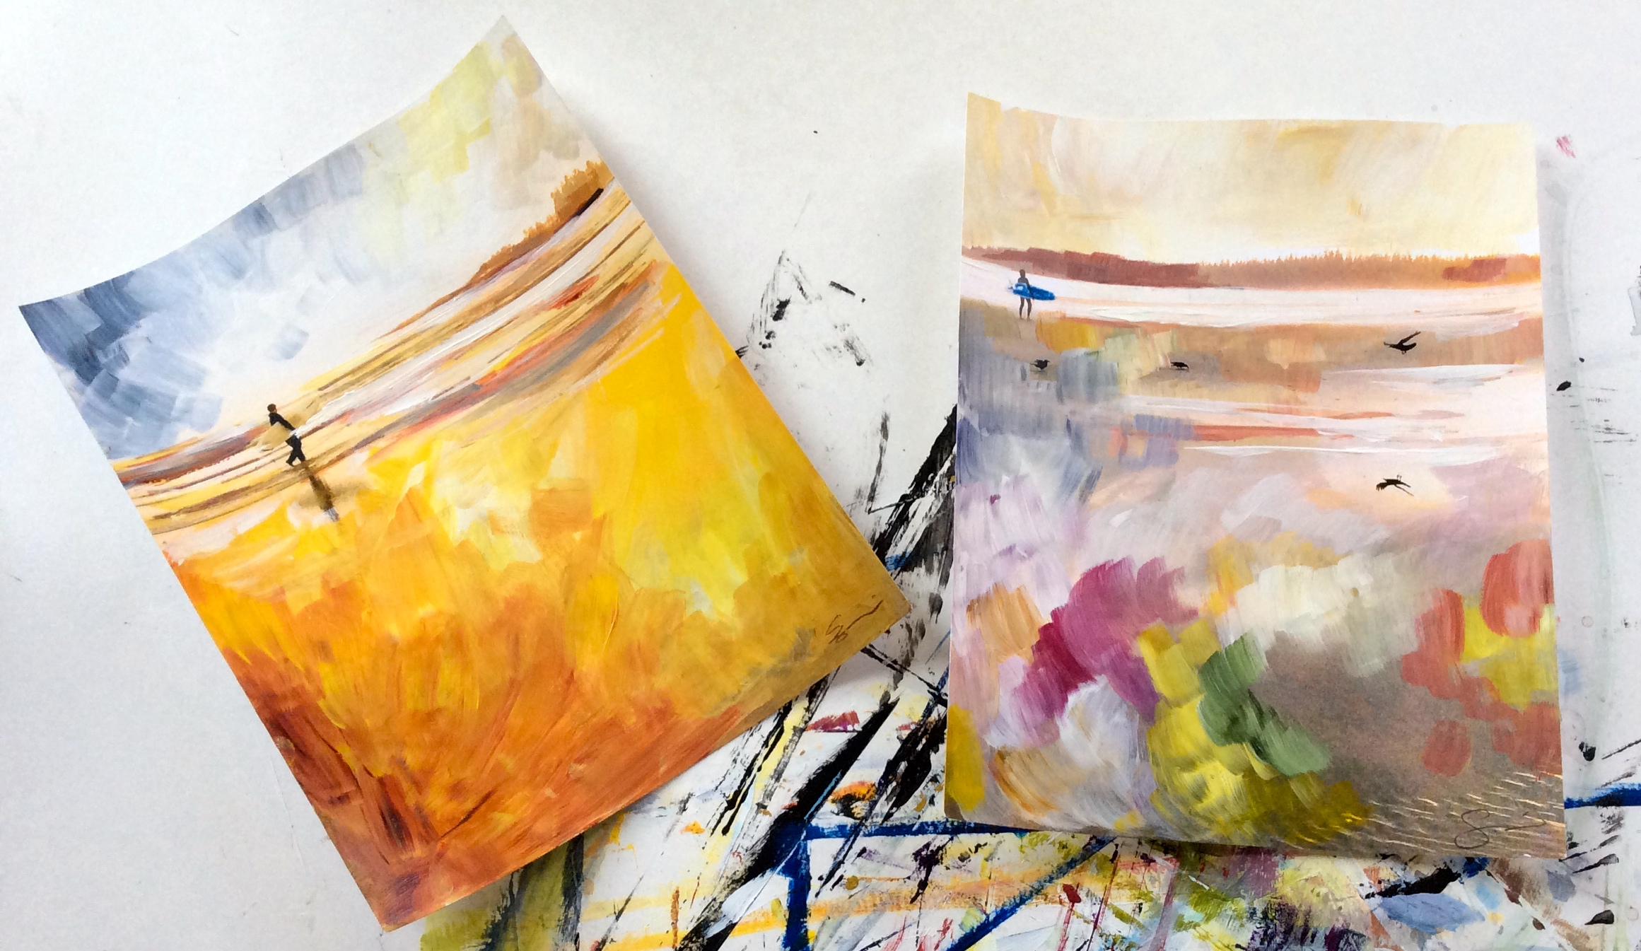 | The Painted Photograph  Step by step class, guests combine black & white photographic imagery and collage with paint to make a cohesive 18 x 30 inch work of art  Barn Board Sign Making  Free work class, Guests make custom signs for there home or office with paint and stencils  Wakefield Community Center classes  https://centrewakefieldlapeche.ca/page-18243  Wakefield Studio Tour:  http://www.tourcw.com/john-pagani-2/ld
  September 2017 | 2017

Monday | Tuesday | Wednesday | Thursday | Friday | Saturday | Sunday
 |  |  |  | 1 | 2 | 3
4 | 5 | 6 | 7 | 8 | 9 | 10

6:30-9:00PM

THE PAINTED PHOTOGRAPH

FALL LANDSCAPE

Accompanied Live Music by Mathew Falvai
11 | 12 | 13 | First Week 14 | 15 | 16 | First week 17
 |  |  | Wakefield Community center:  6:30- Youth Painting at the Wakefield community center (pre- registered) | 7:00-9:00PM  BARN BOARD SIGN MAKING  Accompanied Live Music by Mathew Falvai |  | Wakefield Community center:  -12-1pm parent child craft former  -2-3:30pm Adult acrylic painting ( 8 week pre -registered)
18 | 19 | 20 | 21 | 22 | 23 | 24
 |  |  | 6:30- Youth Painting at the Wakefield community center (pre- registered) |  | Wakefield studio tour -open house -10-5  John Pagani | Community center: 12-1pm parent child craft former  2-3:30pm Adult acrylic painting ( pre -registered)  Wakefield studio tour - open house -10-5 John Pagani
25 | 26 | 27 | 28 | 29 | 30
 |  |  | 6:30- Youth Painting at the Wakefield community center (pre- registered) |  | Wakefield studio tour -open house -10-5  John Pagani

